Monday 1st February 2021
Home Learning
This week when you log into Microsoft TEAMs, things will look a little different. I have created different channels for different subjects/groups.
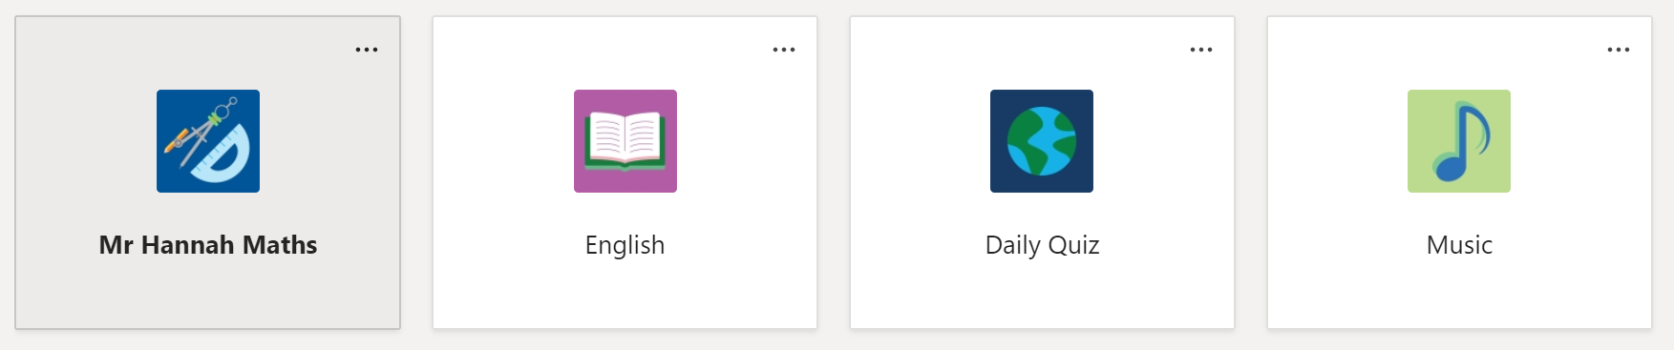
In the English channel, for example, I have posted a video explaining the English for the week.
Please do not comment or post emojis or GIFs in the posts section. I want to keep the channels clear so that they are easy to navigate.
If you have any questions, please email myself or Mrs Wright.
It is really important that you do the daily quiz each day. Thank you.

Maths: Mrs Wright’s group

This week and for the next few weeks we are going to be looking at fractions. Today we are looking at unit and non-unit fractions. Please watch the video from the link below. Questions and answers are attached.
Spring Week 5 - Number: Fractions | White Rose Maths

Maths: Mr Hannah’s group

This week we are looking at Algebra. Attached are todays questions and answers. In our Maths channel on TEAMs, I have recorded a lesson and have gone through the answers to todays questions. This is to replace the White Rose video.

English
On our English channel on TEAMs, there is a video of me explaining this week’s learning.
This week we are going to write a diary recount based on the video clip below:The Egyptian Pyramids - THE LITERACY SHED
Following your feedback, I am going to share all of planning for the week, so you can see how the writing will progress and if you want to crack on and get ahead you can.
After you have watched the video, first you need to decide if you are going to write your diary from the perspective of the archaeologist or the camel. Then you need to divide the video into five sections. Each section will be a paragraph. One paragraph for each day of the week. How you divide the recount is up to you, however, I have put a suggestion below:
- The discovery of the remote.

Describe the archaeologist, where he is and the fact that a camel is in the background

Monday
- How the pyramid rises out of the ground.

How do the camel or the archaeologist feel when the pyramid rises up to show the giant pharaoh?

Tuesday
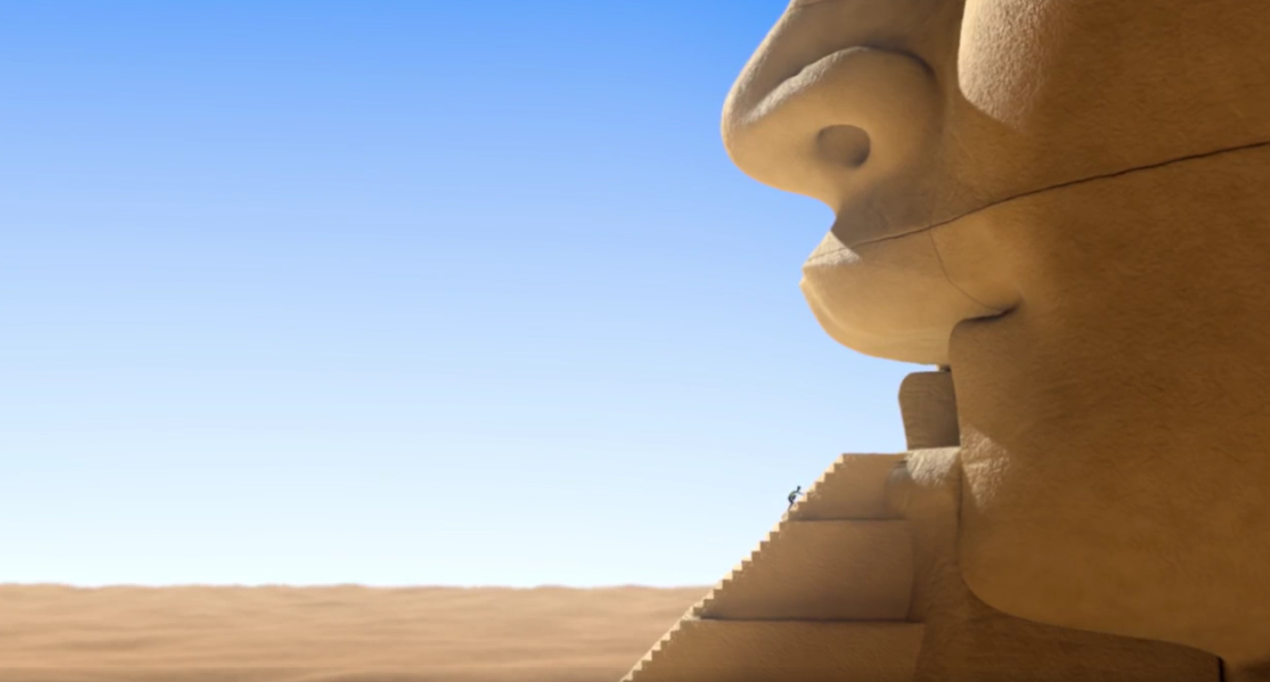 | - The archaeologist climbs into the pharaoh after the stairs come out of his mouth.  Opportunity to be highly descriptive about the statue.  Wednesday
- Camel chews the remote and the statue starts to revolve.

Describe the confusion of the camel/archaeologist.

Thursday
- The camel burps and the archaeologist fly’s out.

Describe the feelings of the camel/archaeologist at the end of the event.

Friday

You can email me your paragraph every day and I will feedback to you.

Success Criteria
Use the past tense.

Use first person pronouns (I, we, my etc).

Describe the camel or archaeologist’s thoughts and feelings.

Use ambitious vocabulary to describe the character and the settings.

Write in an informal style, as if you are talking to someone.

Use time conjunctions to link events.

Organise events into paragraphs.

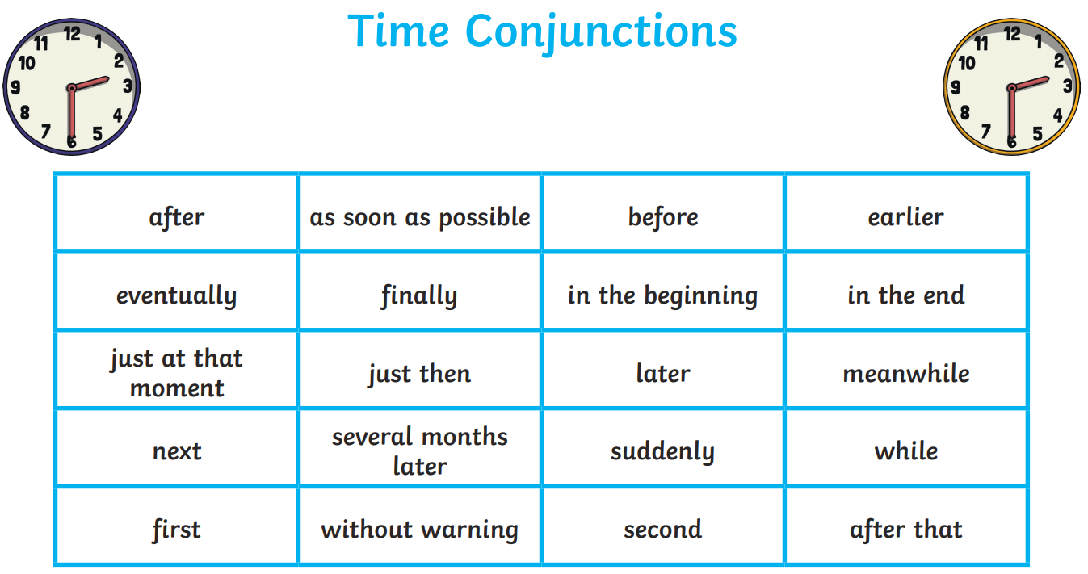

On Friday morning, I would like you all to attend a TEAMs meeting where you will share your writing with a small group and I can give you some feedback.
9.15 – 9.30 | 9.45 – 10.00 | 10.15 – 10.30 | 10.45 – 11.00 | 11.15 – 11.30 | 11.45 – 12.00
Perran  Oscar  Summer  Yasmin  Izzy | Archie  Zach  Alex  Joseph Freddie | Ethan  Ed  Jamie  Peter  Dom | Rose  Amber  Kairah  Tiana  Nadine | Poppy  Carys  Shadae  Mellina | Ryan  Harley  Holly  Afraya  Chloe

Physical Education for the week
Spring Virtual School Games

1st – 5th February
Over the week there are a set of challenges for every day. For every challenge there are points up for grabs. Please can you complete the results form on TEAMs or send any results to Mrs Andrew at sandrew@duloeprimary.co.uk at the end of each school day and we will add to the school total. All results will be submitted on Friday afternoon.
Making up the miles is a challenge that runs throughout the week and the aim is to tally up as many miles as you can by running, walking, cycling, scooting, etc. At the end of the week send in your score!
Monday | R, Y1, Y2 - Hop Little Bunny!  Y3, Y4, Y5, Y6 – Rebound reactions
Tuesday | R, Y1, Y2 - Throw Mr Fox  Y3, Y4, Y5, Y6 – Step up to the plate
Wednesday | All – Around the world
Thursday | All – Slingin superheroes
Friday | Create your own challenge.

