Home Learning 09.02.21
Maths
Today for maths the learning objective for Reception is: to match pairs
Please watch the session 1 video below.
https://whiterosemaths.com/homelearning/early-years/growing-6-7-8-week-2/
Attached is the accompanying activity.

Today for maths the learning objective for Year 1 is: to find 1 more and 1 less with numbers to 50
Please watch the accompanying video – 2nd one more and one less video.
https://whiterosemaths.com/homelearning/year-1/spring-week-6-number-place-value-within-50/
Today in our TEAMs session we will go over questions 1 and 2 and then we will look at questions 3 and 4 together.
Mathletics
Every day there will be one activity assigned to do.

English
Phonics – please watch the video linked to your child’s phonics group
Lynsey’s group – https://www.youtube.com/watch?v=OWYL5F8_TWQ&feature=youtu.be
Mrs Hughes - https://www.youtube.com/watch?v=xNCZQjTqJhU&feature=youtu.be
Mrs Penhaligan - https://www.youtube.com/watch?v=kl1NNUypGUk&feature=youtu.be
Writing
This week is the run up to Chinese New Year and we will be exploring the history and customs behind this festival. Year 1’s will be creating some poetry based on our senses.
Our learning objective today is: to spell words with phonemes already taught
Watch the attached Powerpoint, showing some of the traditions and celebrations during the festival.
Reception – Try the say it, join it sheet using some of the objects that are important during this festival.
Year 1 – After looking through the pictures and information use the sheet to record ideas of the things that we might see, hear, taste, touch and hear during the festival. We will need these lists tomorrow to start writing our poems.

Reading
Please aim to read for 20 minutes every day. Don’t forget to have a look at the books on Oxford Owl and I will be sending out recommended reads emails today to everybody.
Spelling
Well done to everyone who is completing the activities on Spelling frame.
Today’s leader board – Eden, Honor, Millie
Art
This week we will be experimenting with and using line patterns to create effects. At the end of the week we will have created some Chinese dragons.
Our learning objective today is: to experiment creating different line patterns with a pencil
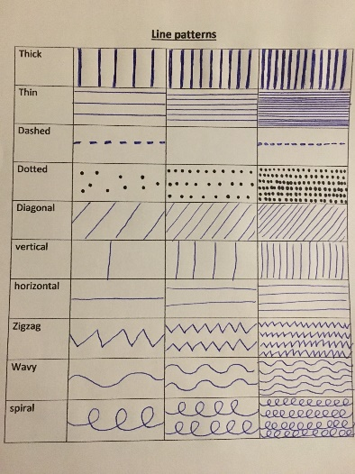
Have a look at my example of different line patterns. Have a go at creating your own chart like mine. You can make the effect lighter or darker by adding in more lines or by putting them closer together.

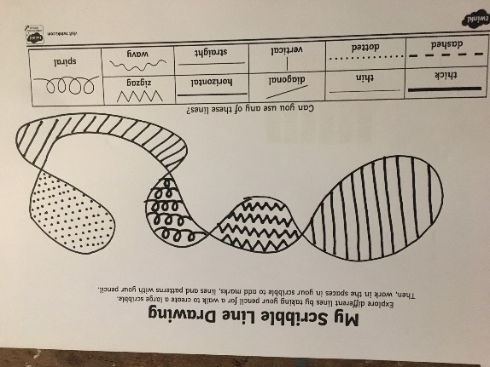

Then “take your pencil for a walk” over your page. In the gaps where the lines overlap add in some different line patterns. You can add colour if you like or just use a writing pencil.
Design Technology
Your objective today is: to evaluate my product
I would like you to take a photo of your finished house an email it to me or put it on Tapestry then complete the evaluation and send me a photo of that too.

