Objective
To create a personal Cartouche using clay.
Having picked up your piece of clay from the box, using your Cartouche you created on paper last week. Model the clay as in the example below. If you make a mistake or are not happy with it reform and start again.
First roll or press your clay out into a flat shape.
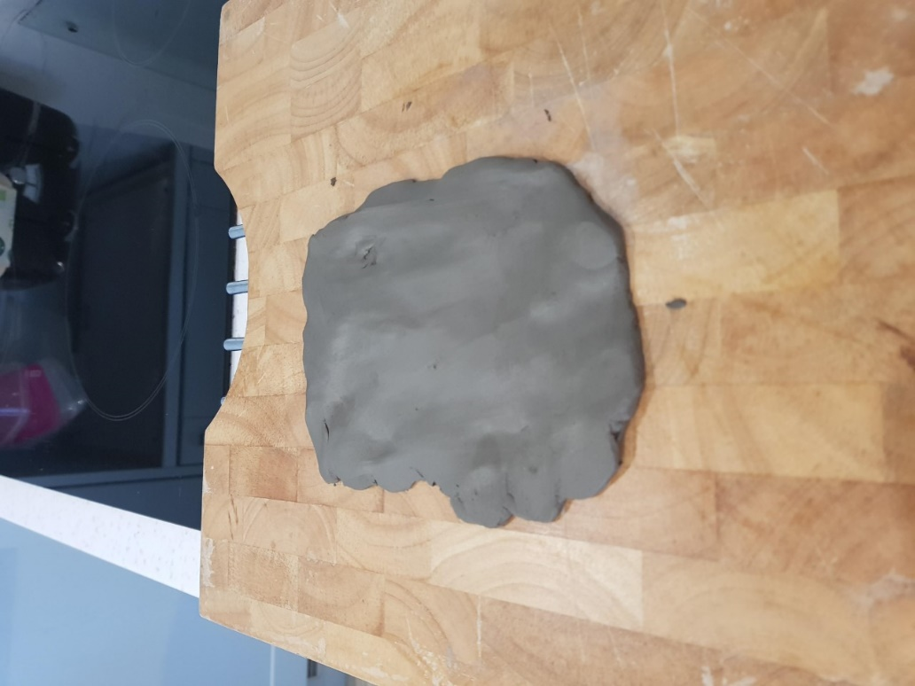
Then using a tool with a point or a sharp pencil (adult supervision required) outline your Cartouche shape.
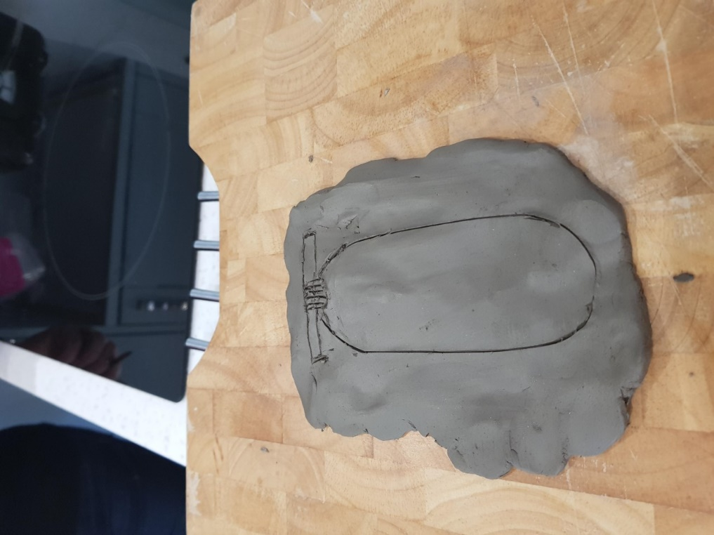
Using your paper Cartouche copy the symbols onto the clay with your tool lightly but clear enough to see the detail.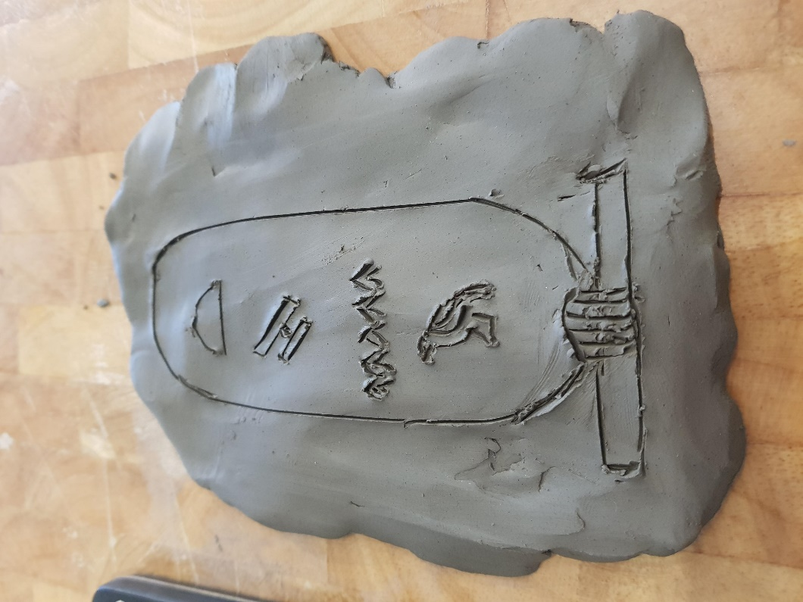
Then very carefully cut around and leave in a warm place to dry out and the clay will harden. (I put mine in the airing cupboard if you have one!)

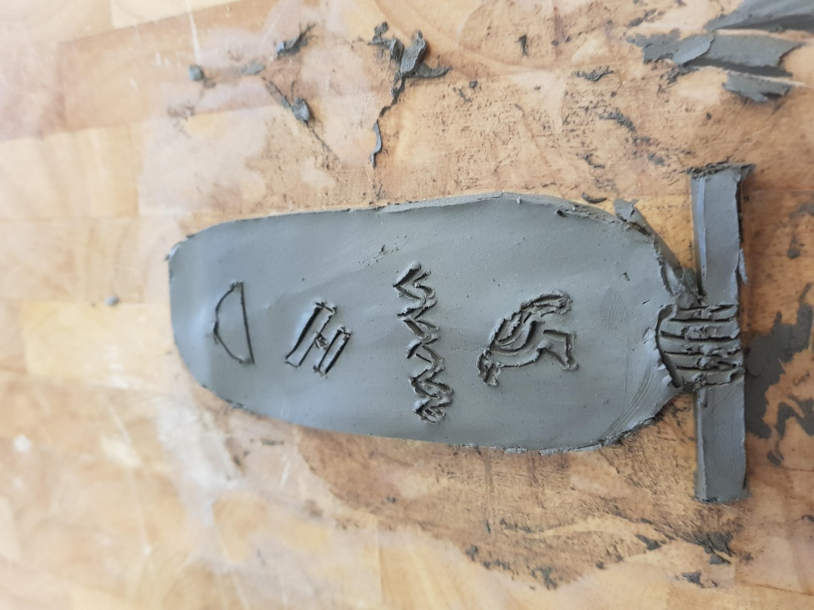
Use paints if you have them to make your Cartouche stand out. There are some examples below.
