Your poem is going to follow a structure like the one below. Today is just a practice to get used to the structure. Our ‘real’ poems will be about Egypt.
It starts with a place and a sense. ( seeing, hearing etc) ‘ In the ocean of dreams I saw ...’

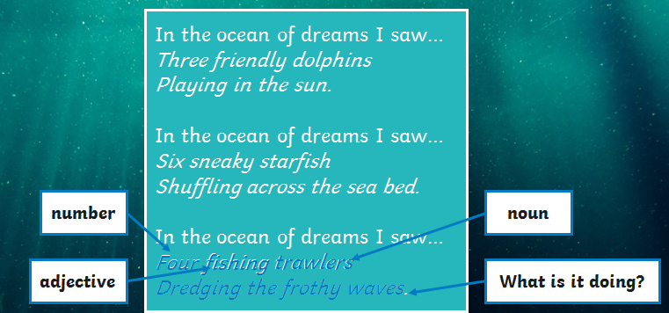
Then there is a number. ( Eg three)
Then an adjective a describing word eg friendly).
Then a noun (something that would be there, eg dolphins).
Then explain what the noun is doing. (the verb eg playing in the sun).

I would like most of you to write another verse to this poem following this structure. Remember this is just to get used to the pattern of the words. We will start thinking about our Egypt poems tomorrow. Challenge: You could write a verse which begins
In the ocean of dreams I heard .....

Please send me your verses if you can!

If you find this very difficult, please try the second English sheet for today.

