Guidance for flower dissection

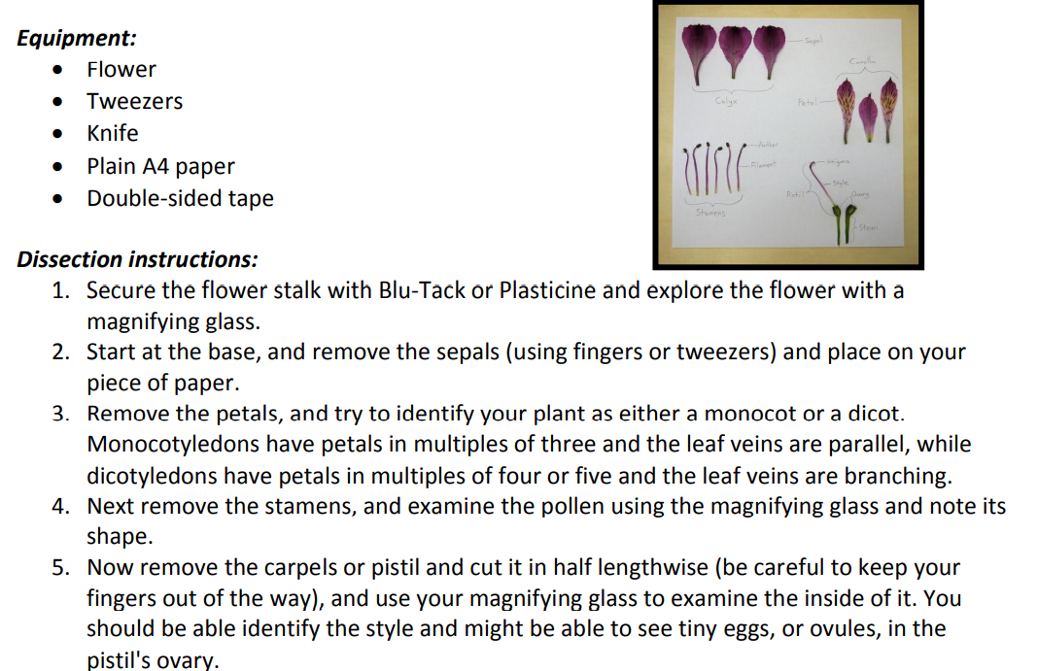
Once completed label each part.

