Wednesday 10th February
Look at the pictures below. Think of things (nouns) which maybe found in these places. Next think of an adjective to describe the noun. Then think of something the noun could do (the verb). Fill in the tables below with your ideas. These words will help you tomorrow to write your poem.
If you have a thesaurus, you could use this to help you. Here is a link to an online thesaurus: https://kidthesaurus.com/
If you get stuck, scroll right to the end – there are some words to help you with the tomb picture. You can choose the words you want. Most of you should be able to come up with ideas for all three pictures.
The tomb of Tutankhamen
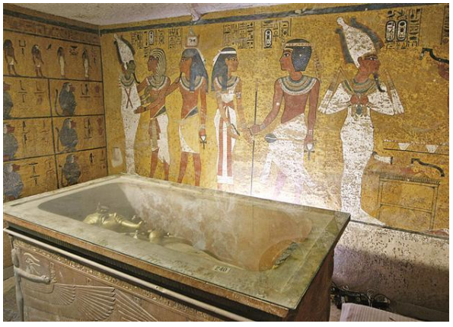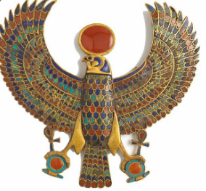
Nouns | Adjectives | Powerful verbs
cobwebs | fragile, silver | dangling

In the land of the pharaohs
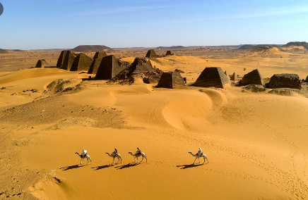
Nouns | Adjectives | Powerful verbs

By the banks of the Nile
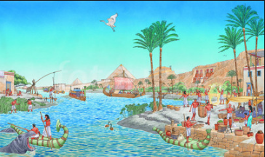
Nouns | Adjectives | Powerful verbs

Some ideas for the tomb ( in case you’re stuck).
Nouns:
Jewels riches stairs corridor perfume
stone cobwebs symbols
mummies sarcophagus walls engravings hieroglyphics weapons

Adjectives:
cold damp warm muggy dirty dark dusty ancient
bone chilling mysterious terrifying musty stale
precious rare sweet beautiful

Powerful Verbs
shimmering glistening staring marching leading defending
creaking gazing resting sprawling reclining

