11.2.21
I hope you all had a good day yesterday. Only today and tomorrow to go everyone (especially the grownups)!
Maths:
You will all need a small box for today’s maths. Wrap up warm and go outside with a grown up. Wrap your grown up nice and warm too – we feel the cold more than you!
How many different objects can be fitted into the box. The objects must be whole things and each one different – so no bits of leaf torn up and stuffed in! Give yourself a specific length of time.

Back inside, sort your objects into metal/wood/ plastic/ plant/ rock/ etc.
Draw a tally chart to show this data.
Challenge: Draw a bar chart to show this data.

I will also set a task on Mathletics to complete today.

English
This week we will be thinking about poetry and how we can use words in a creative way. We will be working towards producing our own poem which follows a structure. I would like us to share our poems on Friday morning through TEAMs. You can choose to either read your poem out or send it into me and I can read it for you.

Today, you will write your poem following the structure we have looked at:
In the ocean of dreams I saw.....
Five friendly dolphins
Frolicking in the froth.

So we start with our place and a sense
Then we have a number, an adjective and a noun.
We finish with what they are doing ( powerful verb).

Our poems will be based in Egypt and I will give you some ideas for how to start verses, but you do not have to use these. The words you came up with yesterday should help you today.
Try and set your poem out in verses with 3 lines in each verse. Each new line should start with a CAPITAL LETTER. You can think about different senses if you want – I heard, I smelt, I felt, I tasted...
Some of you (my phonics group) may only write one or two verses. THAT IS FINE! Some of you may write ten verses. THAT IS ALSO FINE!

The ideas I came up with are from yesterday’s work:
In the tomb of Tutankhamen .....
In the desert of Egypt .....
In the valley of the Nile .....

Timings for tomorrow’s meetings:
9.10 Aidan, William, Mason
9.30: Tashia
9.45: Miyah, Ellie, Holly, Anna, Keira T
10.20: Keira B, Maisie, Bea, Oscar, Ryan, Oliver
10.45: Seb, Logan, Jago, Kyle, Lucas, Jake
11.05: Rowan, Stan, Emily, Cece, Ottilie

Spellings:
Everybody please spend 15 minutes on Spellingframe. Your words will change each week and I will be checking who is on the leader board! At the moment, Jago is in the lead followed by Kyle, Keira T, Bea, Seb and Aidan. All these names will be put in the blue box for when we all come back to school. Well done you six!

Reading:
Please read for about 20 minutes and talk about what you have read to a grown up.

Art/ History
We are going to make an Egyptian collar necklace using things you might have at home. Pasta shapes which have been painted work really well for this! Below you will find some information about Egyptian jewellery and then some examples that you might want to use to inspire you!
I will attach a design sheet if you want to design it first.

Please send me a photo of you wearing your necklace if you are able to.
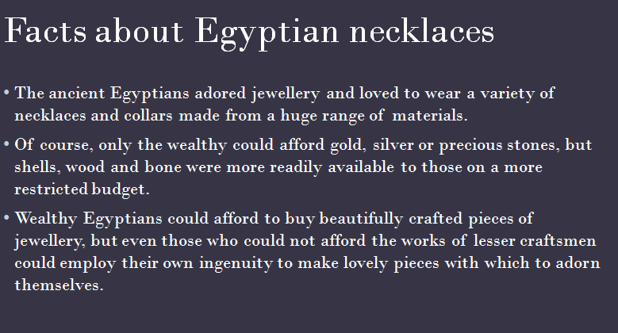

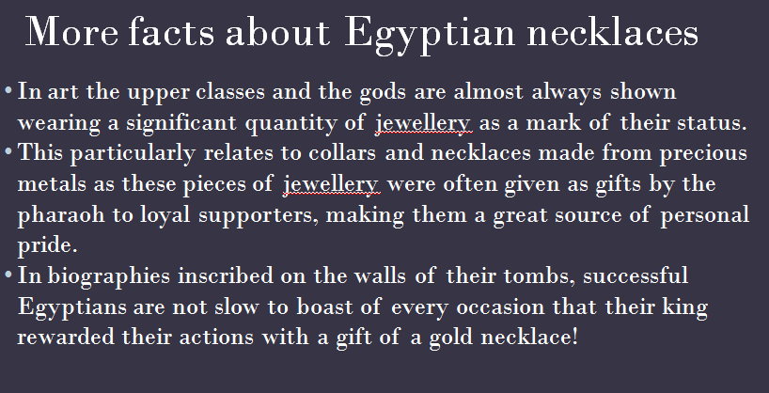

Ideas to inspire:
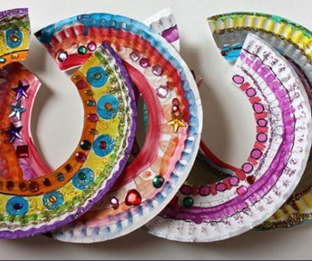 Paper plate collars.

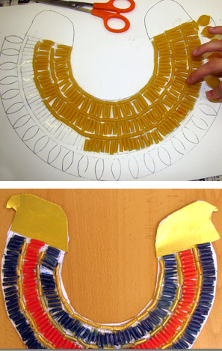 Using pasta onto card.
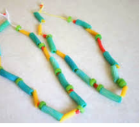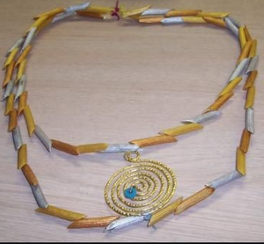
Threading pasta ideas
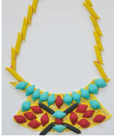

Using different bits and bobs:
