Home Learning 11.02.21
Maths
Today for maths the learning objective for Reception is: to combine 2 groups
Please watch the session 4 video below.
https://whiterosemaths.com/homelearning/early-years/growing-6-7-8-week-2/
Attached is the accompanying activity.

Today for maths the learning objective for Year 1 is: to compare numbers within 50
Please watch the accompanying video
https://whiterosemaths.com/homelearning/year-1/spring-week-6-number-place-value-within-50/
Complete the attached sheet.
Mathletics
Every day there will be one activity assigned to do.

English
Phonics – please watch the video linked to your child’s phonics group
Lynsey’s group – Live session with Lynsey today – please have a go at the attached sheet to apply the phonics taught
Mrs Hughes - https://www.youtube.com/watch?v=dFqFWbIV-vo&feature=youtu.be
Mrs Penhaligan - https://www.youtube.com/watch?v=JNaUCoWd9e8&feature=youtu.be
Writing
This week is the run up to Chinese New Year and we will be exploring the history and customs behind this festival. Year 1’s will be creating some poetry based on our senses.
Our Reception learning objective today is: to spell words using our phonics
Reception – Complete the senses poem for Chinese New Year. What could you see, hear, taste, touch and smell during the festival. Use the attached powerpoint for a recap.
Our Year 1 learning objective today is: to re-read what they have written to check it makes sense
Year 1 – Today I would like you to re-read your first draft of your senses poem and then create a second draft (or annotate the original copy) by adding in some extra information by using adjectives, to describe what your objects are like and verbs to explain what the objects are doing.
For example
I can see red and gold decorations.
I can hear fireworks exploding.
When you have added in this extra information to each verse, read through again and check that the poem makes sense and you are happy with it.
Reading
Please aim to read for 20 minutes every day.
Spelling
Well done to everyone who is completing the activities on Spelling frame.
Today’s leader board – Lilly S, Eden, Honor
Art
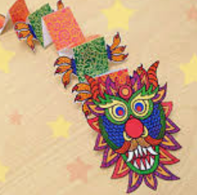
This week we will be experimenting with and using line patterns to create effects. At the end of the week we will have created some Chinese dragons.
Our learning objective today is: to produce patterns and textures
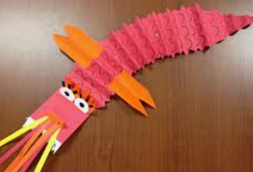
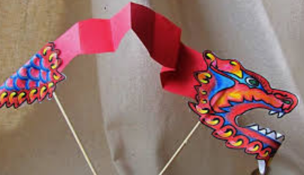
Today I would like you to create a Chinese Dragon.
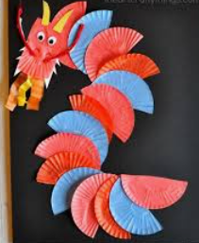
You can choose how you would like to make your dragon but on each part of the dragon body I would like you to create a different pattern – diagonal lines, circles, waves, dots, what ever pattern you fancy. Try to use line patterns rather than colours. Each section could be a different colour. Remember red is a very lucky colour for the Chinese people and especially during this festival.
When your body is complete, draw and cut out a dragon head that can then be stuck onto the dragon’s body.
R.E.
Mrs Wright would like you to share the story of David and Jonathan and discuss how it shows a story of friendship.

