English wb 08.02.21
This week we are going to use our knowledge that we have developed about Egypt to write a poem. On Friday, after the success of last weeks TEAMs group meetings to share our writing, we are going to do the same.

We are going to use a poem that we have used before to give us the starting point for our poems. The poem is ‘The Magic Box’ by Kit Wright.

Our plan for the week, looks like this:
Monday | Tuesday | Wednesday | Thursday | Friday
Watch the TEAMs video about the poem and analyse the features.  Look at the WAGOLL example of the poem. | Watch the Horrible Histories video about Egypt (link below) and take notes about the features of Egypt that you wish to include within your poem. | Draft your poem using the success criteria and looking at the example poems as guidance.  There will a live drop in TEAMs meeting where you can read me your poem and I will give you feedback. | Edit your poem, thinking carefully about your vocabulary choices. Make sure it is punctuated correctly. | Perform your poem to your class mates on TEAMs.

Horrible Histories - Awful Egyptians | Compilation - Bing video
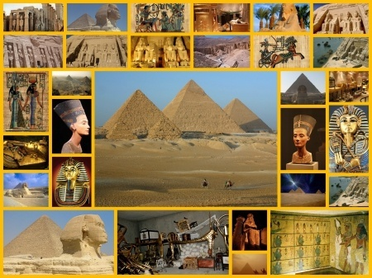

The Magic Box
I will put in the box:
the swish of a silk sari on a summer night,
fire from the nostrils of a Chinese dragon,
the tip of a tongue touching a tooth.
I will put in the box
a snowman with a rumbling belly
a sip of the bluest water from Lake Lucerene,
a leaping spark from an electric fish.
I will put into the box
three violet wishes spoken in Gujarati,
the last joke of an ancient uncle
and the first smile of a baby.
I will put into the box
a fifth season and a black sun,
a cowboy on a broomstick
and a witch on a white horse.
My box is fashioned from ice and gold and steel,
with stars on the lid and secrets in the corners.
Its hinges are the toe joints of dinosaurs.
I shall surf in my box
on the great high-rolling breakers of the wild Atlantic,
then wash ashore on a yellow beach
the colour of the sun.
The Magic Sarcophagus

I will put in the sarcophagus:

a sphinx sitting silently surveying the sand,
the cartouche of a lost relative,
King Tut’s treasured tomb.

I will put in the sarcophagus:

a pharaoh with a generous heart,
the life-giving nourishment of the Nile,
a sacred cat with a deadly secret.

I will put in the sarcophagus:

the desire of a Roman emperor,
the final wish of a forgotten slave
and the first placed stone of a pyramid.

I will put in the sarcophagus:

a lost Rosetta and a new hieroglyph,
a mummified Osiris
and a dead ruler leading the underworld.

My sarcophagus is fashioned from power and jealousy and murder,
with treasures on the lid and lost valleys in the corners.
Its hinges are the reeds on the river bed.

I shall cruise in my sarcophagus
over the unforgiving sands of the Sahara,
then arrive within my new life,
to begin my rule again.

