Friday 12th February 2021
It is really important that you do the daily quiz each day. Thank you.
Maths: Mrs Wright’s group

Objective: Count in fraction. Questions and answers attached. Video link below:
Spring Week 6 - Number: Count in fractions| White Rose Maths
Please email me if you have any questions: twright@duloeprimary.co.uk

Maths: Mr Hannah’s group

There is a recorded lesson on our TEAMs channel today because on the English groups this morning. Well done everybody for your two weeks of algebra! Attached are questions/answers related to the lesson.

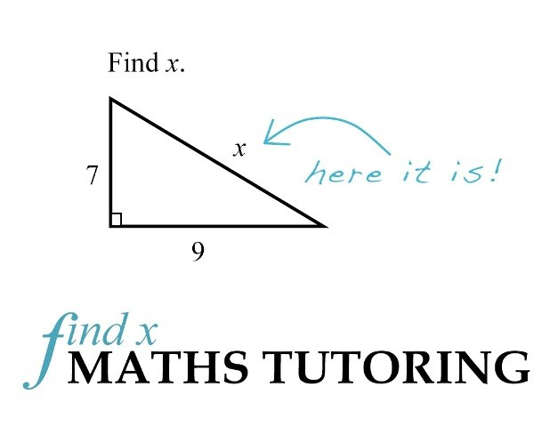

English
I would like you to share your poems with a small group on TEAMs today. I am more than happy to read your poems if you would like me to. Times and groups below:
9.15 – 9.30 | 9.45 – 10.00 | 10.15 – 10.30 | 10.45 – 11.00 | 11.15 – 11.30 | 11.45 – 12.00
Perran  Oscar  Summer  Yasmin  Izzy | Archie  Zach  Alex  Joseph Freddie | Ethan  Ed  Jamie  Peter  Dom | Rose  Amber  Kairah  Tiana  Nadine | Poppy  Carys  Shadae  Mellina | Ryan  Harley  Holly  Afraya  Chloe
Thank you for all the drafts you have sent in so I can give feedback.
Science
See attached documents.

