Tuesday 23rd February 2021. Lesson on TEAMs at 11.00am (will be recorded).
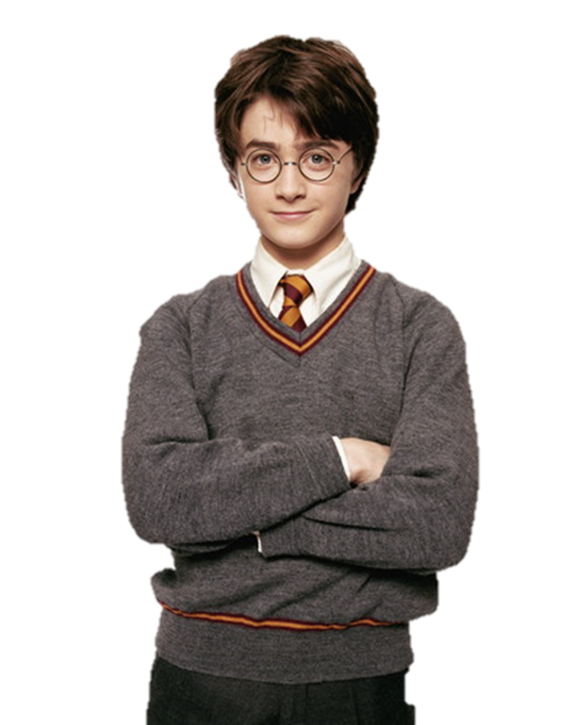
LO: to describe a character.

Today we are going to be focusing on the different characters from Harry Potter!
Can anyone name some of the characters?

- When describing a character from a book or movie we focus on 2 things:
- Appearance:
  - How a person looks Eyes, face, hair, scars or distinctive marks.
- Personality:
  - What a person is like Mean, nice, happy, sad.

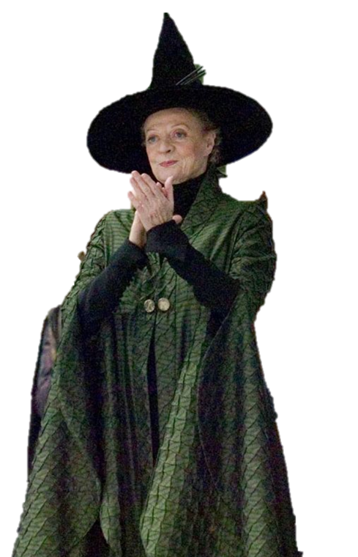
WAGOLL: Professor McGonagall

“A rather severe-looking woman who was wearing square glasses exactly the shape of the markings the cat had had around its eyes. She, too, was wearing a cloak, an emerald one. Her black hair was drawn into a tight bun. Professor McGonagall almost always showed a sternness and was held in great respect (and some fear) by nearly all students and staff. She didn’t tolerate audacity nor silliness from her pupils and was known to turn cold towards people who said or did things in front of her that were stupid. However, she did have a dry sense of humour which usually came out when times were tough.”

Success Criteria
Must | Describe part of their personality | Must: 5 sentences
Must | Describe part of their appearance
Must | Expanded noun phrase
Must | Co-ordinating conjunction
Should | Fronted adverbial
Should | Adventurous vocabulary choice | Must: 100 words
Dazzle | Parenthesis
Dazzle | Hyphen
Click on the characters below to see a short video clip of their best bits from the films.
