Tuesday 23rd February 2021
It is really important that you do the daily quiz each day. Thank you.
Maths: Mrs Wright’s group

Objective: Adding fractions. Questions and answers attached. Video link below:

Spring Week 7 - Number: Fractions | White Rose Maths

Please email me if you have any questions: twright@duloeprimary.co.uk

Maths: Mr Hannah’s group

There will be a live lesson on TEAMs at 9.10am this morning. It will be recorded if you cannot attend.

Questions and answers attached.

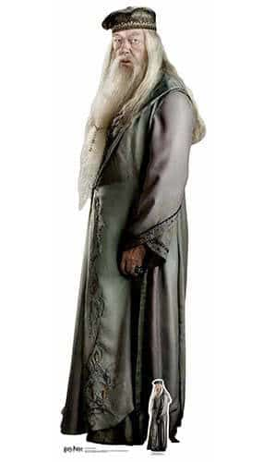
English
There will be a live lesson for all of the class today at 10.45am via TEAMs, again this will be recorded if you cannot attend the session. Relevant documentation is attached. We are going to be focusing on Harry Potter this half-term!

Class Story
At 1.05pm Mrs Wright will be reading the first chapter of The Philosopher’s Stone. We will have a class story at this time every day via TEAMs until we return to school.

Reading Comprehension
Attached is a differentiated reading comprehension which links to character description from the mornings English lesson. Star 1 is the easiest text and Star 3 is the hardest text. Answers are also included.

Physical Education
Please check out Joe Wicks lockdown workout from yesterday: (250) PE With Joe 2021 | Monday 22nd Feb - YouTube

