Wednesday 24th February 2021

Learning Objective: using dialogue to develop

WAGOLL

Mrs Dursley came into the living- room carrying two cups of tea. It was no good. He’d have to say something to her. He cleared his throat nervously. ‘Er – Petunia, dear – you haven’t heard from your sister lately, have you?’
As he had expected, Mrs Dursley looked shocked and angry. After all, they normally pretended she didn’t have a sister. ‘No,’ she said sharply. ‘Why?’
‘Funny stuff on the news,’ Mr Dursley mumbled. ‘Owls … shooting stars … and there were a lot of funny- looking people in town today …’
‘So?’ snapped Mrs Dursley.
‘Well, I just thought … maybe … it was something to do with … you know … her lot.’
Mrs Dursley sipped her tea through pursed lips. Mr Dursley wondered whether he dared tell her he’d heard the name ‘Potter’. He decided he didn’t dare. Instead he said, as casually as he could, ‘Their son – he’d be about Dudley’s age now, wouldn’t he?’
‘I suppose so,’ said Mrs Dursley stiffly.
‘What’s his name again? Howard, isn’t it?’
‘Harry. Nasty, common name, if you ask me.’
‘Oh, yes,’ said Mr Dursley, his heart sinking horribly. ‘Yes, I quite agree.’
He didn’t say another word on the subject as they went upstairs to bed.

Success Criteria
Must | The dialogue displays the personality of the character. | Must: 5 sentences only
Must | Start a new line when a new person speaks.
Must | Directs speech mark at the beginning of direct speech.
Must | Punctuation at the end before the direct speech mark.
Must | Capital letter after the opening direct speech mark. | Must: 100 words at least.
Should | Use a question.
Should | Use other sentences that do not include direct speech.
Dazzle | Match said words with the content of what is being said.
Dazzle | Ellipsis and dashes to show pauses in conversation.

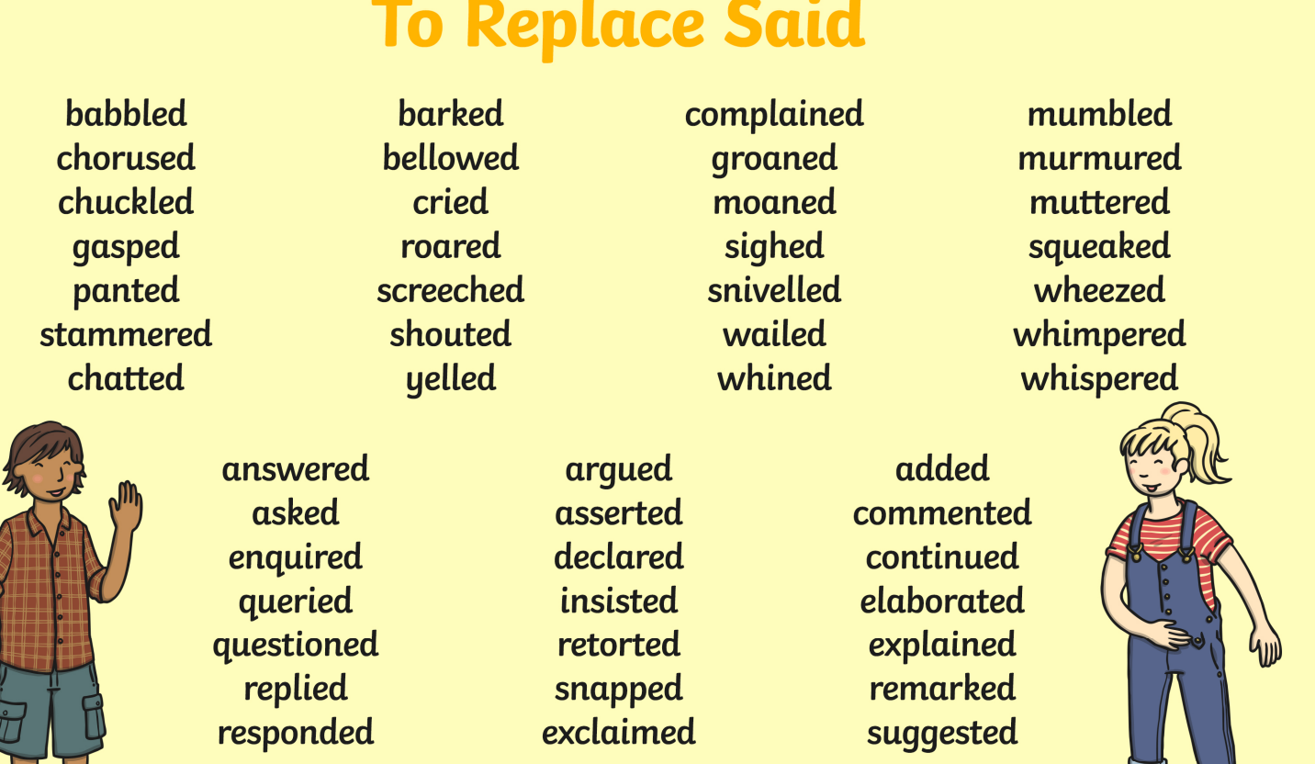
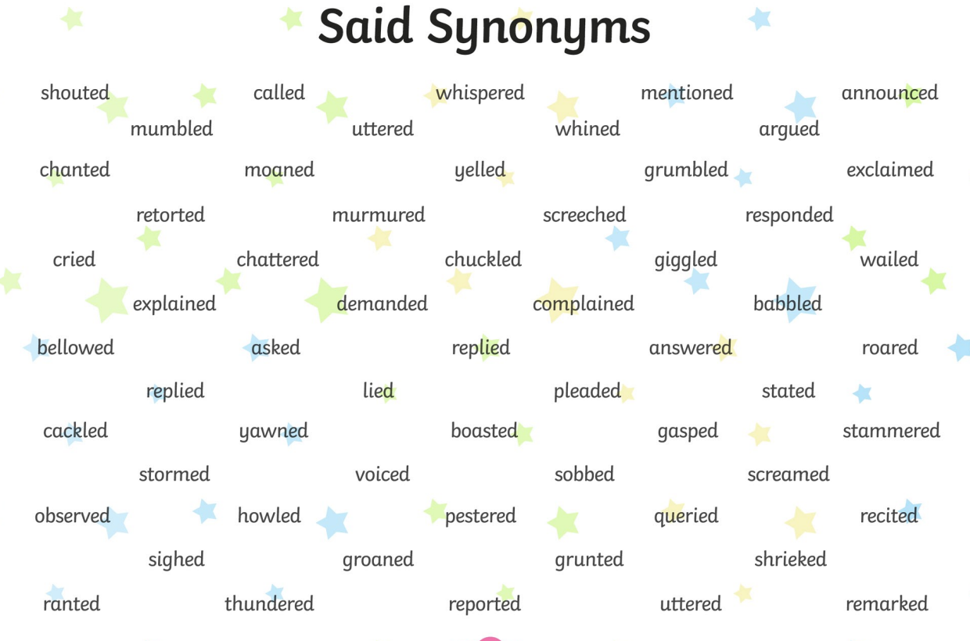

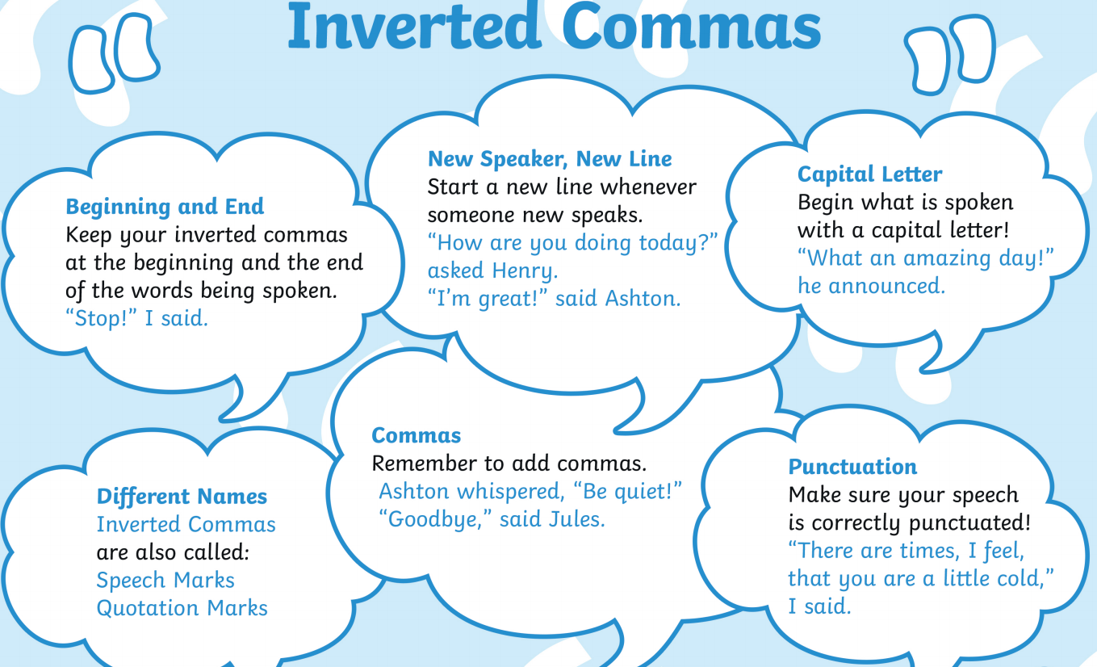

You are going to write a dialogue between your character from yesterday and another Harry Potter character of your choice.
