Home Learning 24.02.21
Maths
Today for maths the learning objective for Reception is: to compare length
Please watch the session 2 video below.
https://whiterosemaths.com/homelearning/early-years/growing-6-7-8-week-3/
Attached is the accompanying activity.

Today for maths the learning objective for Year 1 is: to count in 2’s
Please watch the accompanying video, session 2
https://whiterosemaths.com/homelearning/year-1/spring-week-7-number-place-value-within-50/
Complete as much of the attached sheet as you can.
Mathletics
Every day there will be one activity assigned to do.

English
Phonics – please watch the video linked to your child’s phonics group
Lynsey’s group – Live phonics session with Lynsey
Mrs Hughes - https://www.youtube.com/watch?v=6AiVFK9SMj0&feature=youtu.be
Mrs Penhaligan - https://www.youtube.com/watch?v=5fT_U2_BUfI&feature=youtu.be
Writing
Today I would like you to look at the picture of the worm. What words could we use to describe it? Pink, wriggly, long, etc.
Explain that this is not a normal worm, it is a Superworm. Now what words might we use to describe it? Speedy, strong, etc.
Our Reception learning objective today is: to segment the sounds in simple words
Reception – Use sound talk to spell the words you want to write. List 3 words to describe the worm and then 3 more when you know it is super!
Our Year 1 learning objective today is: to spell words containing the phonemes taught
Year 1 – We will do this session together via TEAMs at 1:30.
We will list words to describe the worm in the picture using our phonics and sound talk, pink, long, wriggly, etc. Then add to our list after discovering that the worm is a Superworm, amazing, strong, speedy, etc.
Then share the story of Superworm.
Superworm - https://www.youtube.com/watch?v=7Jnk3XApKBg
Reading
Please aim to read for 20 minutes every day. Don’t forget to access the Oxford Owl website with the books relevant to your child’s phonic stage. If you need any help with this then please get in touch.
See how many different Julia Donaldson books you can hear over this half term. You can find lots online to listen to.
Spelling
Well done to everyone who is completing the activities on Spelling frame.
The leader board currently stands at – Olly, Honor, Quinn
Science
Our objective today is: Science – to observe changes across the four seasons
The weather is spring can be very different every day. Today we are going to start a weather diary. Attached is a booklet that you can use or you can create your own. We will be keeping a diary of the weather for a week, starting with today. Each day write down the day and draw pictures and write words to explain what the weather is like outside your window.
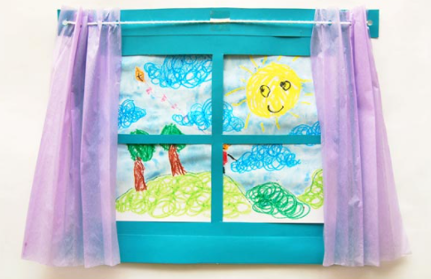
Today I would also like you to create a picture of what you can see today, like the one below. Include any signs of spring that you can see, use the checklist from yesterday or include any signs that you spotted.

P.E.
Join in with a cosmic yoga.
https://www.youtube.com/watch?v=4q252Wnp4oM&list=PL8snGkhBF7ngiFwW6-b9aV5eCgY0FAAB4&index=38

