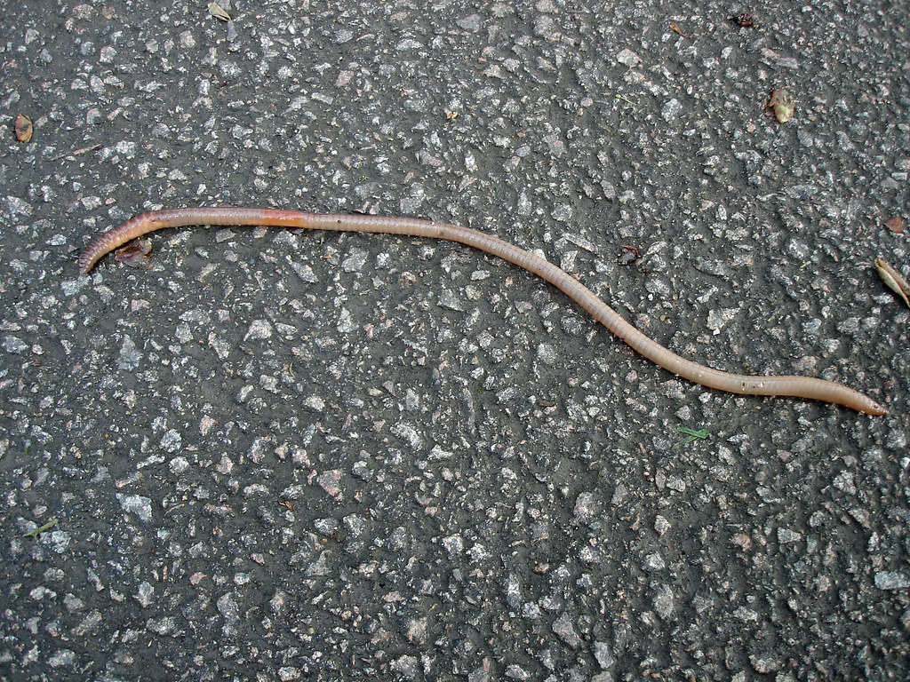

Which words would you use to describe the worm?
________________________________________________________________________________________________________________________________________________________________________________________________________________________________________________________________________________________________________________________________________
What about now you know he is a ‘Superworm’? ________________________________________________________________________________________________________________________________________________________________________________________________________________________________________________________________________________________________________________________________________

