Superworm
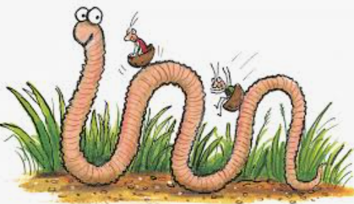

Complete the sentence

Superworm is ________________________________________
___________________________________________________

