Superworm
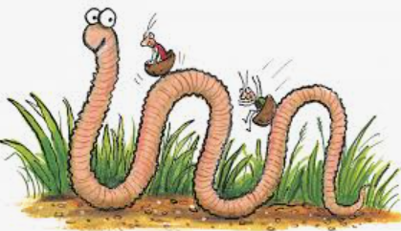

Write 3 sentences to describe Superworm

1. Superworm is _______________________________________
___________________________________________________
2. _________________________________________________
___________________________________________________
3. _________________________________________________
___________________________________________________

