To link the properties of rocks to their uses.
To be able to identify different types of rock.
To link the properties of rocks to their purpose in a real – life context.

Rock and Use | Properties
Granite worktop
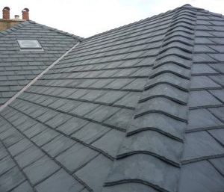
Slate roof

Limestone statues

