Josh and Ella were playing in the garden. “Don’t go far.” said Josh’s uncle . “It will be time for lunch soon.”
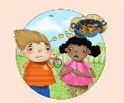
Josh didn’t feel like eating lunch. “What’s wrong?” Ella asked. “My uncle’s lamb curry is horrible!” Josh said.

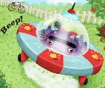
Just then there was a sound. A little spaceship was in the garden. A purple thing with tentacles shuffled out of a spaceship. “Who are you?” asked Ella. “The Purple Muncher,” said the thing.

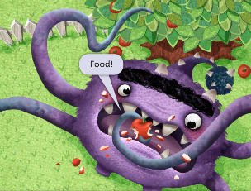
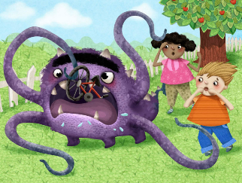
With one tentacle it grabbled an apple from the tree. “Food!” it cried. It gobbled the apple in under a second. “I need food!” Cried The Purple Muncher. Its tummy gurgled. Josh unwrapped a bit of bubble gum. The Purple Muncher grabbled the bubble gum and began to chew. It dribbled on its chin. Then it gulped. “You don’t EAT bubble gum!” said Ella. The Purple Muncher’s tummy rumbled.

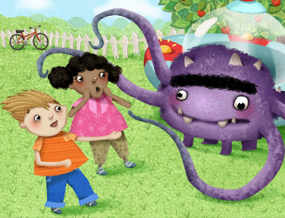
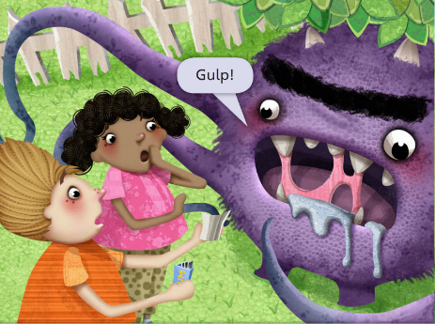
“I need food!” it cried. “I can’t get food for you,” said Josh. The Purple Muncher grabbed Mum’s bicycle and began to eat! “That’s impossible!” cried Ella. But Ella was wrong. The Purple Muncher ate every little bit and finished with a burp. It gnashed its teeth. “I NEED FOOD!”

It started eating the apple tree. “Don’t!” cried Josh. But the Purple Muncher went on eating. “This is terrible!” Said Ella.
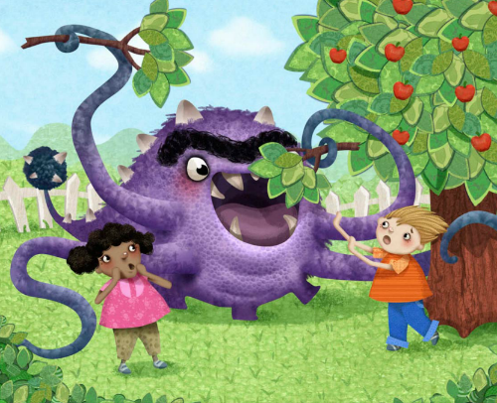

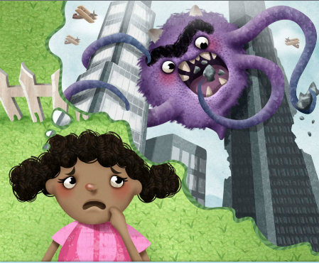
“Is it going to eat the house next? Then the town? Then the Earth? What can we do?

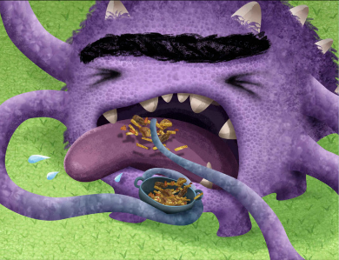
“I know!” said Josh. He ran in to the house. Five seconds later he was back with a bowl. “Try this,” he said. The Purple Muncher reached out a tentacle and took the bowl. It has a nibble, then shouted, “YUCK! HORRIBLE!”
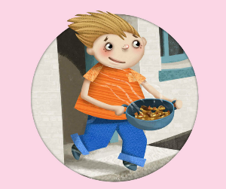

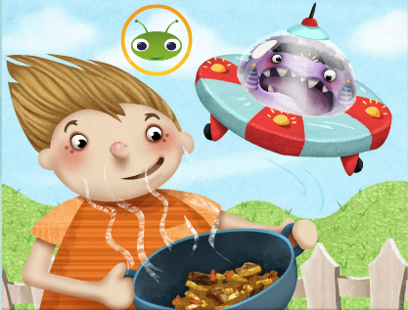
It climbed back to the spaceship and zoomed off. “See?” said Josh with a smile. “I told you my uncle’s lamb curry is terrible!”

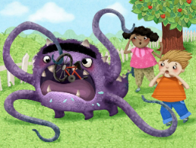

- Why did Josh’s uncle not want the children to go far?
____________________________________________________________________________________________________
- Why did Josh not want his lunch?
____________________________________________________________________________________________________
- What was the name of the thing that came out of the spaceship?
____________________________________________________________________________________________________
- What did the Purple Muncher use to grab the apple from the tree?
____________________________________________________________________________________________________
- What did the Purple Muncher’s tummy do?
____________________________________________________________________________________________________
- The Purple Muncher ate something of Mum’s, what was it?
____________________________________________________________________________________________________
- What things did Ella think the Purple Muncher might eat next?
____________________________________________________________________________________________________
- What was Josh’s idea to feed the Purple Muncher?
____________________________________________________________________________________________________

