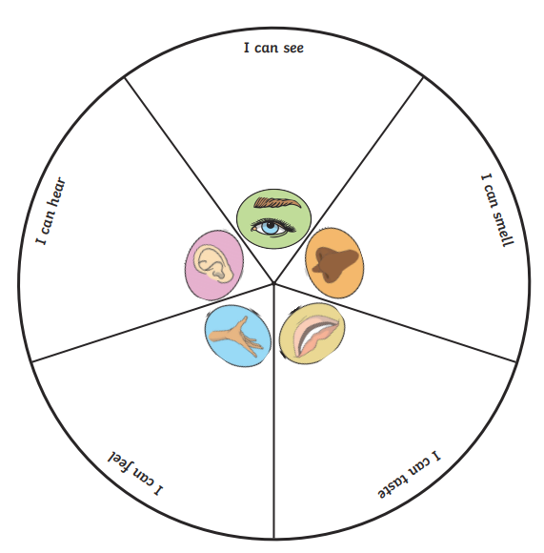
Tuesday 2nd March 2021

I can taste:
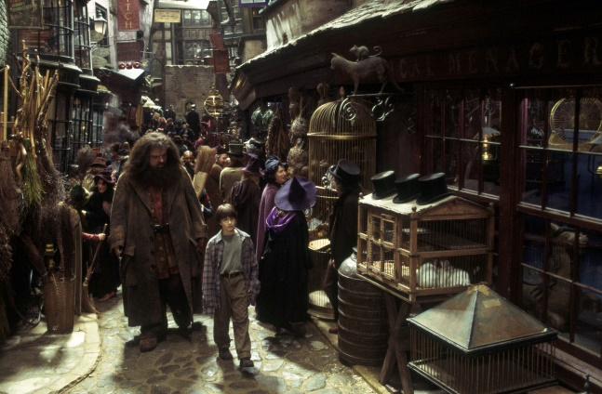
Scrumptious toffee apples.
Delicious ice-cream

I can smell:
The rancid odour of bat dropping.
The fresh aroma of baked bread.
A pungent waft of gas from a bubbling cauldron.

I can hear:
The grating creak of the bricks as they moved in front of me.
Noisy children chattering to one another as they look into shop windows with envy.
The shrill call of a majestic owl surveying the ally
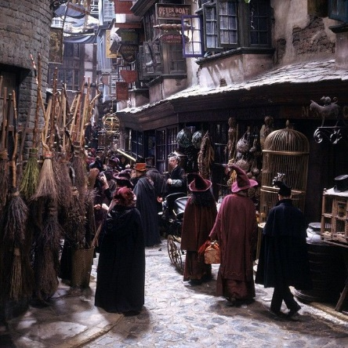
I can feel:
The abrasive fabric of Hagrid’s coat.
The silky, smooth skin of a frog.
The warm air and steam rises around me.

I can see:
Higgledy-piggledy building crowding over me.
Cobbled streets full of people in old-fashioned clothes.
Shops selling all sort of strange and magical items.
Dark, shadowy shops, selling secret potions.

Learning objective: to write a range of sentence structures.

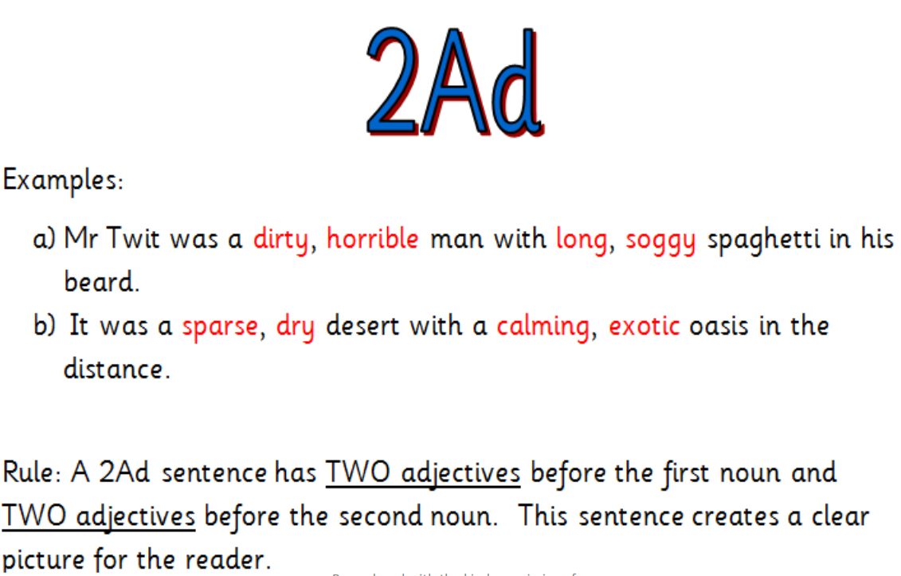

WAGOLL:
I could see a majestic, regal owl with soft, speckled feathers.

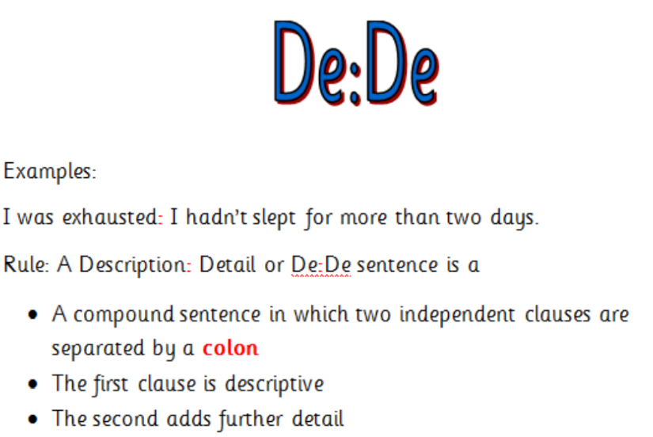

WAGOLL:
There was a shop selling cauldrons: pungent, putrid smells rose from the bubbling potions.

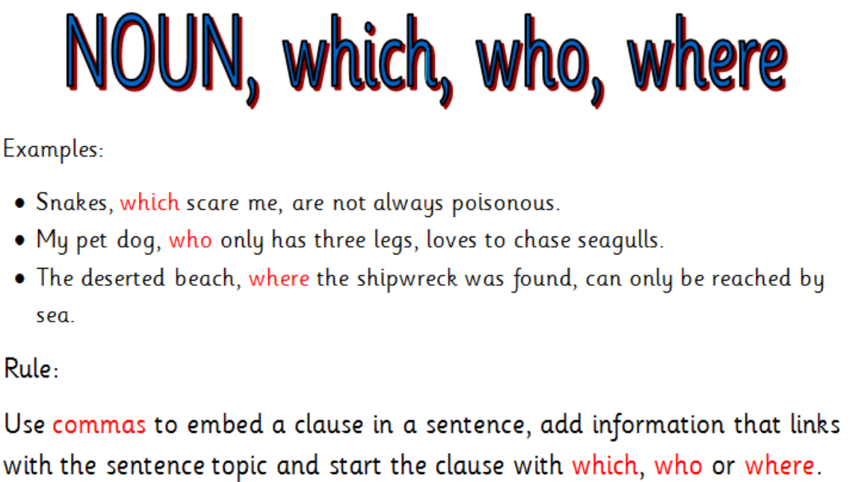

WAGOLL:
The children, who chattered noisily to one another, pressed their noses up against the glass window to stare at the Nimbus 200.

