Wednesday 3rd March 2021

Below are some examples of the 5 sentences children wrote yesterday which they entered in the TEAMs ‘chat’.
Before you move onto todays writing, you need to complete this activity following the instructions from yesterday.

I could smell disgusting, rancid owl droppings, but also delightful, charming bread coming from the crooked bakery.
I couldn’t see anything: people crowded around the shop that had the Nimbus 2000 in, I could tell it was special.
The more Hagrid shoved the bread in his mouth, the more crumbs fell on the floor.
Hagrid, who is a giant, could see over the humongous crowd of people.
Hagrid had told me to meet him at the ancient bakery, but I was fascinated by this snow-white owl.

I could see the ally, which was crowded, was full of children looking at the newest and fastest broomstick through the glass.
I could hear the noise of the bricks moving, so that Hagrid and I could enter the ally.
The more I walked through the mysterious ally, the more I could smell bat and owl droppings.
I could taste the fresh, dry bread that had come out of a bakery and sticky, tasty toffee apples.
I was amazed: I had never felt the air of true wizards blowing in my face.

The wall, which was moving in front of me magically, formed a cloud of dust.
My face was full of excitement, and everywhere I looked there was more and more to see.
Hagrid’s hands felt rough and sweaty, and his grip was hard and painful.
The more we walked, the more variants of smells inhaled through our nostrils.
My cheeks ached: I can’t remember the last time I smiled as much as this.

The more I looked up, the more scared I got of the buildings collapsing.
The shop was selling delicious food: scrumptious, yummy smells were spreading across the alley.
The people, who were crammed together, were making me get a headache.
I thought I could feel an owl nudging me, but it was a man barging past.
I could taste the hot, flavoured bakery bread and the cold, tasty ice-cream.

I could see a soft, beautiful owl with shiny, white feathers.
There was an ice-cream shop: fresh, sweet minty smells came from inside.
The people, who chattered loudly to one another, ate scrumptious toffee apples.
The more I walked along the cobbled alley, the more I became excited.
The old and odd buildings made a shadow over the people, so it was hard to see where they were.

Hagrid was a welcoming, gracious man with a long, shaggy beard and an immense brown coat.
I was amazed: I had never had such a bewildering birthday.
I could taste the delicious toffee apple, which had caramel inside, as I waited for Hagrid.
The more exited Harry became, the more he wanted to stay.
I was joyfully talking to someone about what was it like at Hogwarts, but Hagrid Knocked on the window and said, “Come one Harry.”

Learning Objective: to write a cohesive paragraph.
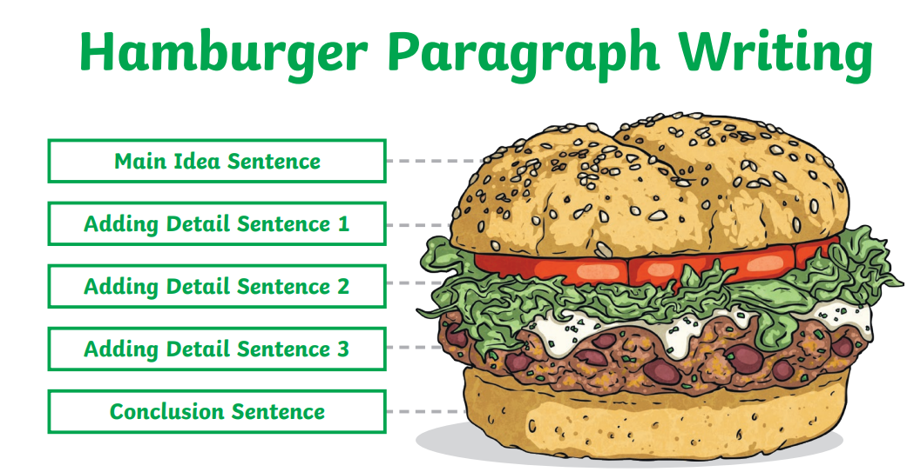

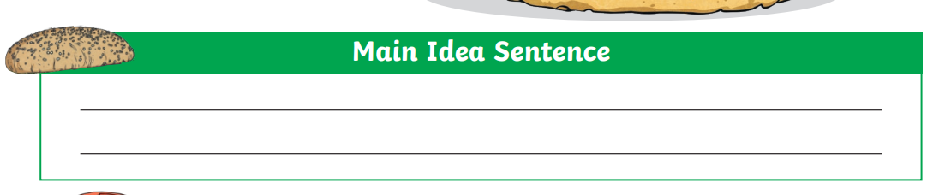

Harry entered Diagon Alley.

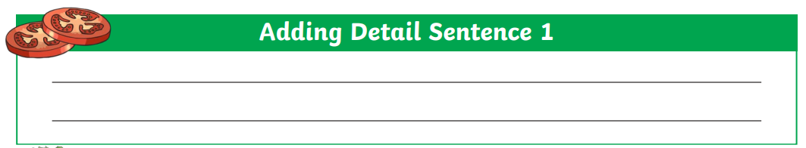

The more he stepped along the cobbled path, the more amazed he was by the bustling mayhem of the place.

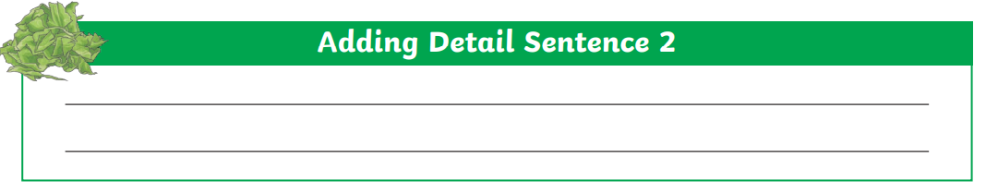
A higgledy-piggledy arrangement of shop, which sold everything a young wizard could need, cast a shadow on all of the strangely dressed people frantically moving below.

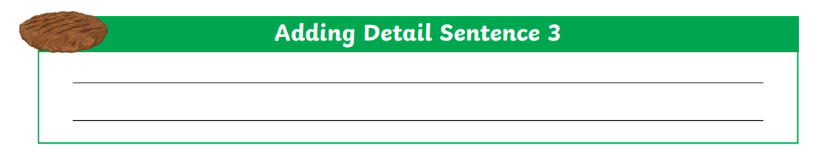
Screeching, squawking owls stood on patrol over the alley, while pungent, putrid aromas wafted from cauldrons on the pavement.

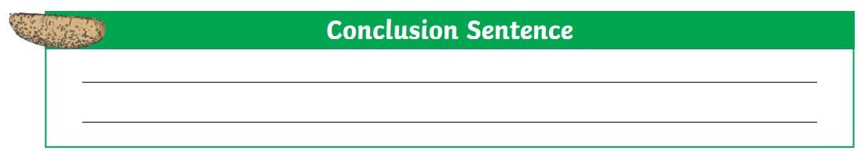
Harry was truly astounded: never had he witnessed such a truly remarkable and magical place.

WAGOLL:

Harry entered Diagon Alley. The more he stepped along the cobbled path, the more amazed he was by the bustling mayhem of the place. A higgledy-piggledy arrangement of shop, which sold everything a young wizard could need, cast a shadow on all of the strangely dressed people frantically moving below. Screeching, squawking owls stood on patrol over the alley, while pungent, putrid aromas wafted from cauldrons on the pavement. Harry was truly astounded: never had he witnessed such a truly remarkable and magical place.

(only 84 words).

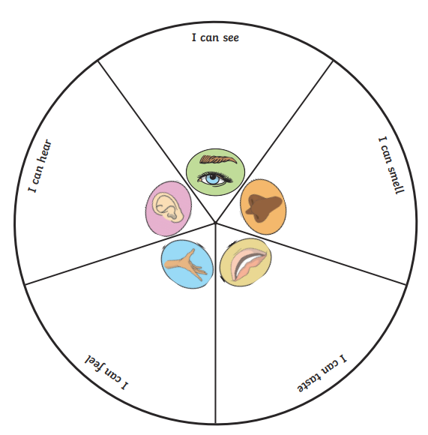
Tuesday 2nd March 2021

I can taste:
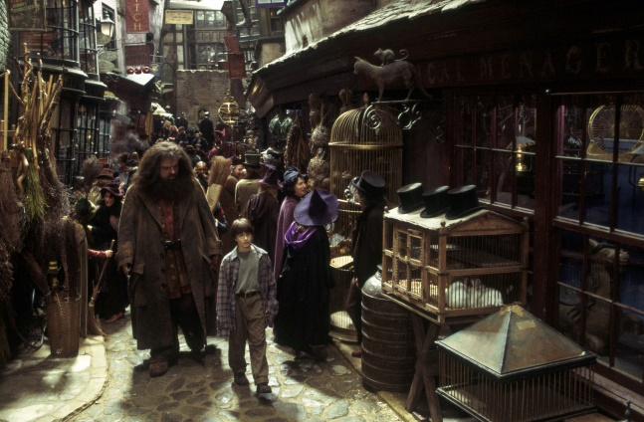
Scrumptious toffee apples.
Delicious ice-cream

I can smell:
The rancid odour of bat dropping.
The fresh aroma of baked bread.
A pungent waft of gas from a bubbling cauldron.

I can hear:
The grating creak of the bricks as they moved in front of me.
Noisy children chattering to one another as they look into shop windows with envy.
The shrill call of a majestic owl surveying the ally
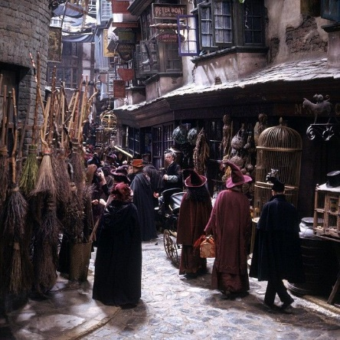
I can feel:
The abrasive fabric of Hagrid’s coat.
The silky, smooth skin of a frog.
The warm air and steam rises around me.

I can see:
Higgledy-piggledy building crowding over me.
Cobbled streets full of people in old-fashioned clothes.
Shops selling all sort of strange and magical items.
Dark, shadowy shops, selling secret potions.

Learning objective: to write a range of sentence structures.

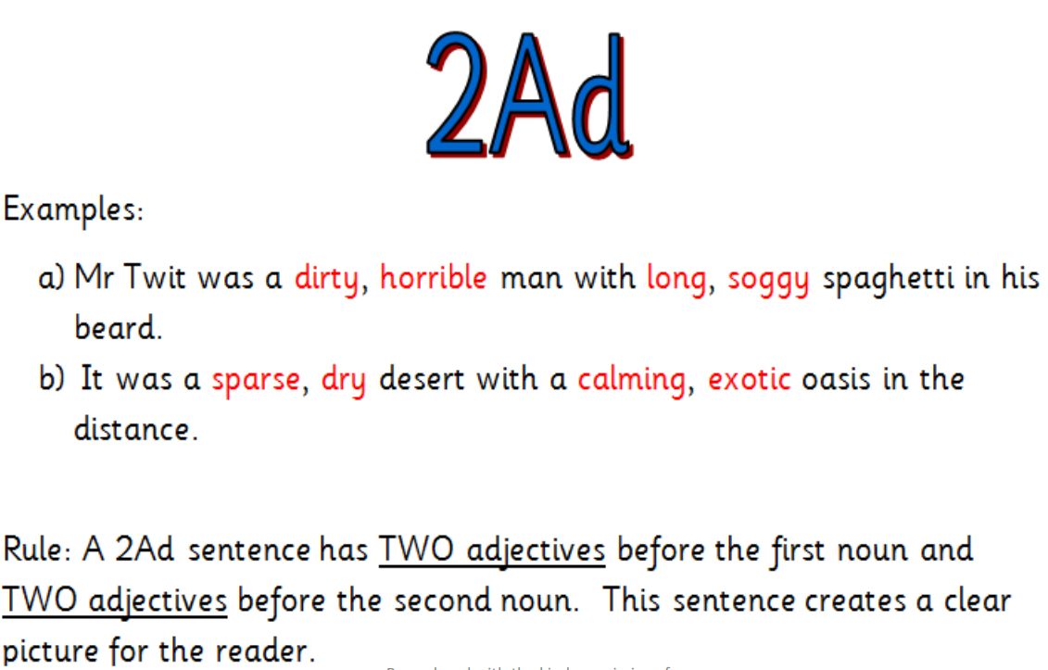

WAGOLL:
I could see a majestic, regal owl with soft, speckled feathers.

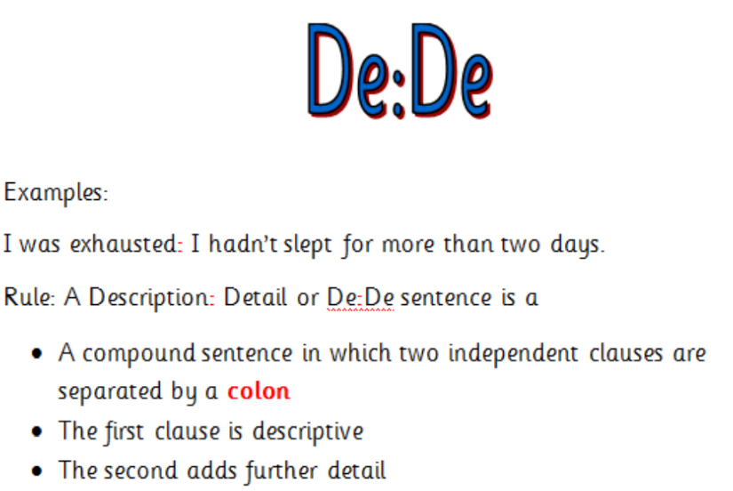

WAGOLL:
There was a shop selling cauldrons: pungent, putrid smells rose from the bubbling potions.

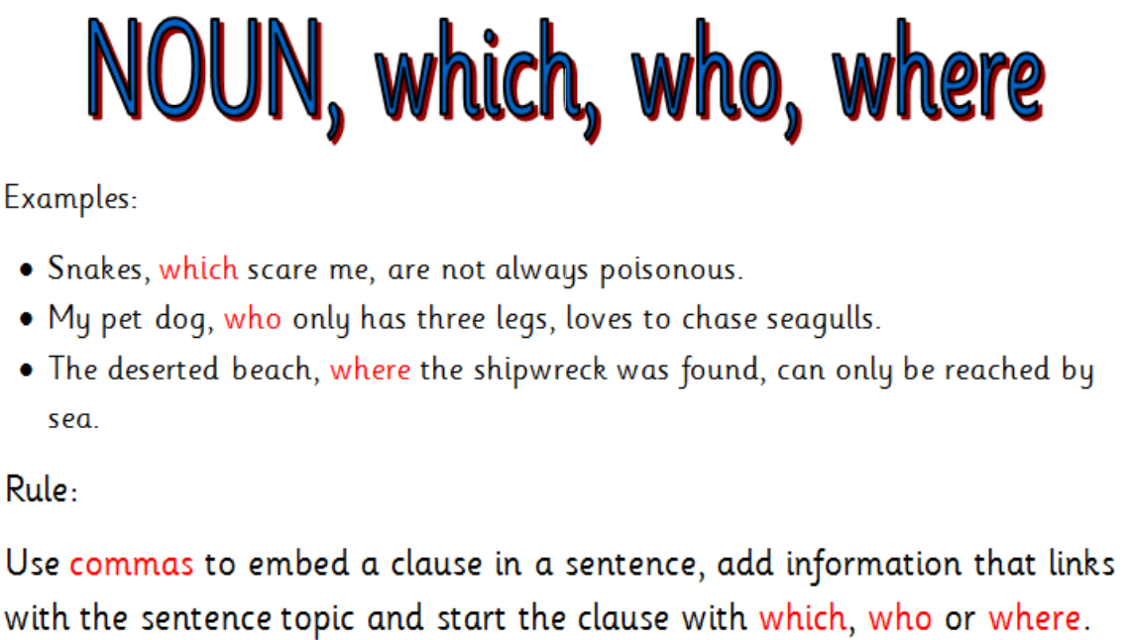

WAGOLL:
The children, who chattered noisily to one another, pressed their noses up against the glass window to stare at the Nimbus 200.

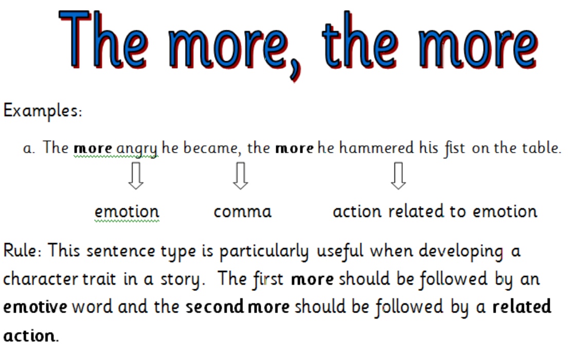

WAGOLL:
The more I travelled along the cobbled alley, the more discombobulated I became.
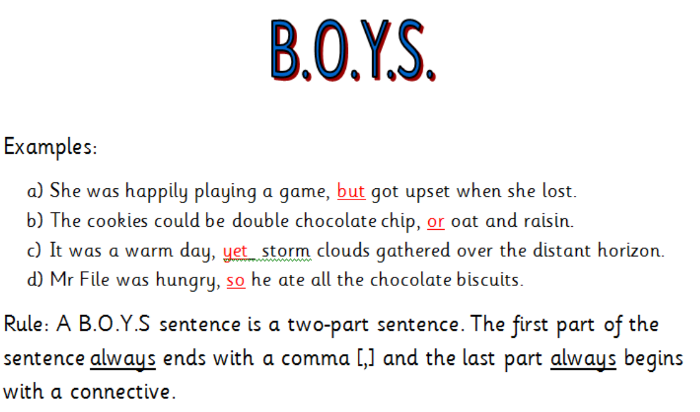

WAGOLL:
The higgledy-piggledy shops cast a shadow over the alley, so it was difficult to make out everything that was going on.

I would like you to write 5 sentences, using each of the structures above once. When you have completed this, I would like you to write them into the ‘chat’ function in TEAMs on the English channel please.

