Can you think of animals that rhyme?
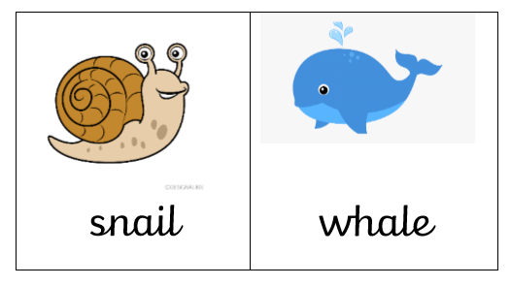
Draw a picture and write the animal names.

