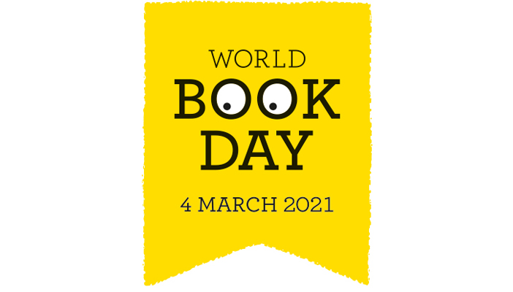
World Book Day will be very different to other years but we hope you still manage to get involved and have some fun.
We would like you to create a piece of art inspired by your favourite book. It can be in any style and using any media. You may want to recreate the front cover of your book using whatever art materials you have at home. You could recreate it in the style of a famous artist. Maybe you could create a portrait of the main character. Or perhaps you want to create a scene from the book. Perhaps you could make a model of the main character? It’s up to you!
We would like you to bring your finished art into school so that we can make a wonderful display of our favourite books in the school entrance hall. All the visitors who come to school will be able to see all the different types of books we enjoy.

DON’T FORGET TO JOIN YOUR CLASS STORYTIME ON TEAMS! You can guess who all the children and staff have dressed up as!
We have an exciting music workshop at 11:15 with the Cornwall Music Trust, all about St Piran in preparation for St Pirans day celebrations on Friday. Click on the link below.
https://youtu.be/88rddyRoQQc

You may also want to try some of the wonderful online activities which are available:

Share a story and try out some of the downloadable activities:
https://www.worldbookday.com/share-a-story-corner

Join a master class with a well known author:
https://www.worldbookday.com/online-masterclasses

Win a prize! Enter the National World Book Day ‘Design a book token’ competition!
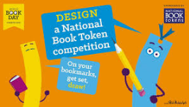

For details on how to enter and the template: https://www.worldbookday.com/competitions/design-a-national-book-token2021/

